Instructions for navigating in the Clockwise web application



by Asherov Gabriel, Bartl Michael, Meyer-Mölleringhof Maximilian, Neumair Jonas

# **Landing Page**

The Landing Page consists out of a total of three parts. The login and registering part, the information part and the about part.

## **Login and Registering**

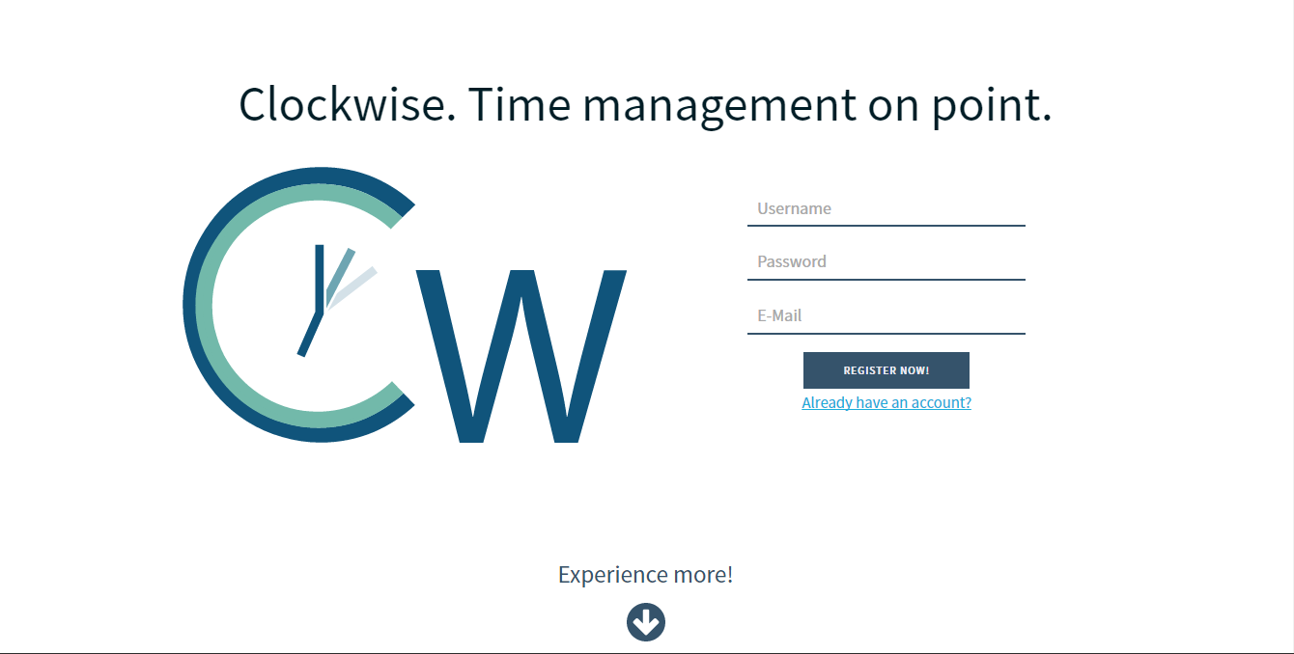The login and registering part is the first part of Clockwise the user is presented with.

*P1.1: The user is presented that screen when loading the page*

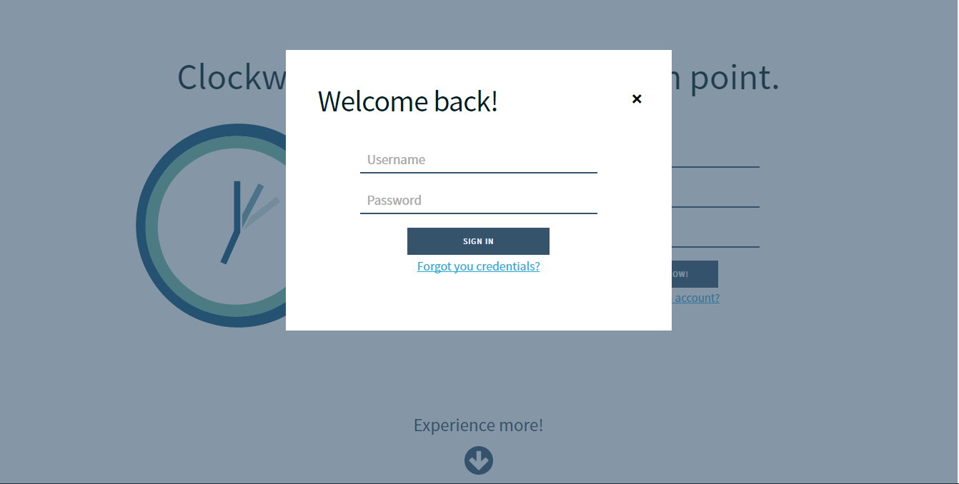From there the user can directly enter his / her credentials (Username, Password, E-Mail) for registering. After having done that he / she is supposed to click the *Register* button in order to be registered.  
However if the user already has an account he / she is supposed to click on the *Already have an account?* link.

*P1.2: The login in pop up is shown when clicking Already have an account? button*

The pop up presented offers the user to enter his / her username and password in order to get logged in.

## **Specification Part**

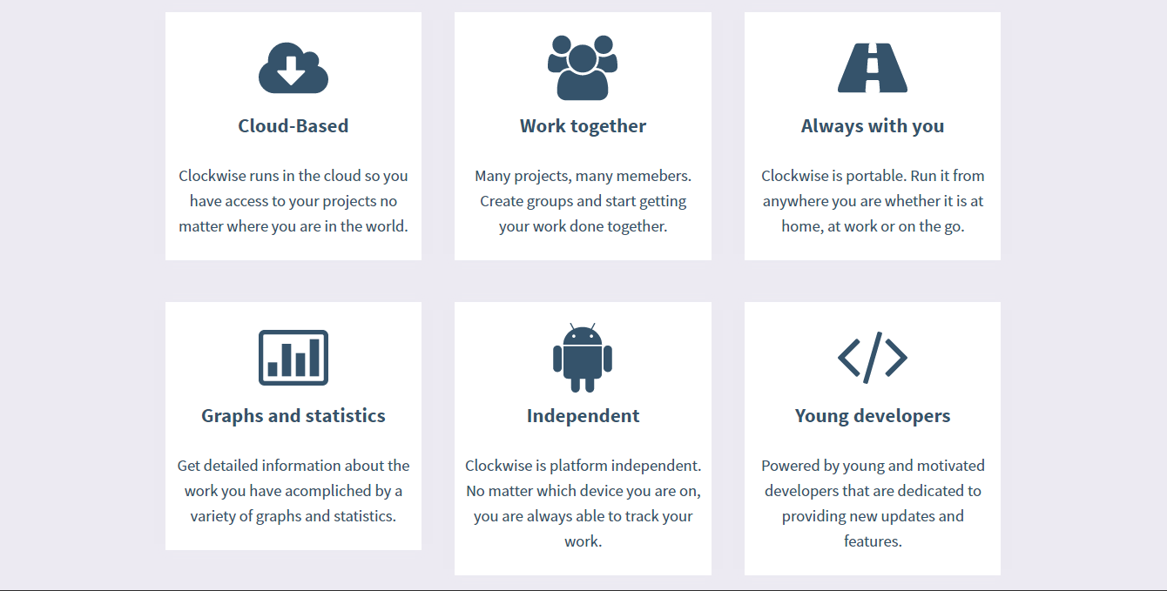When scrolling down from login and registering part the user will find a section describing the features of Clockwise. There are no further actions that can be taken from that part except from scrolling further.

*P1.3: Six cards giving an overview of basic specifications of Clockwise*

## **About Part**

On the bottom the page the user finds the footer part. It gives information about the project team and also gives he possibility to find out about each developer’s GitHub profile by clicking on the different pictures. On the very bottom the user can also go to the main page of GitHub. In addition, there is a link to the person who provided the different icons being used in Clockwise.

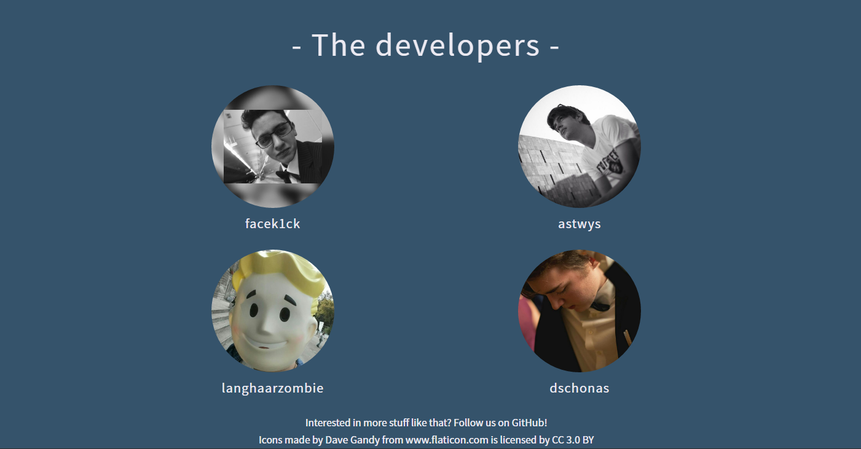

*P1.3: Six cards giving an overview of basic specifications of Clockwise*

# **Project View**

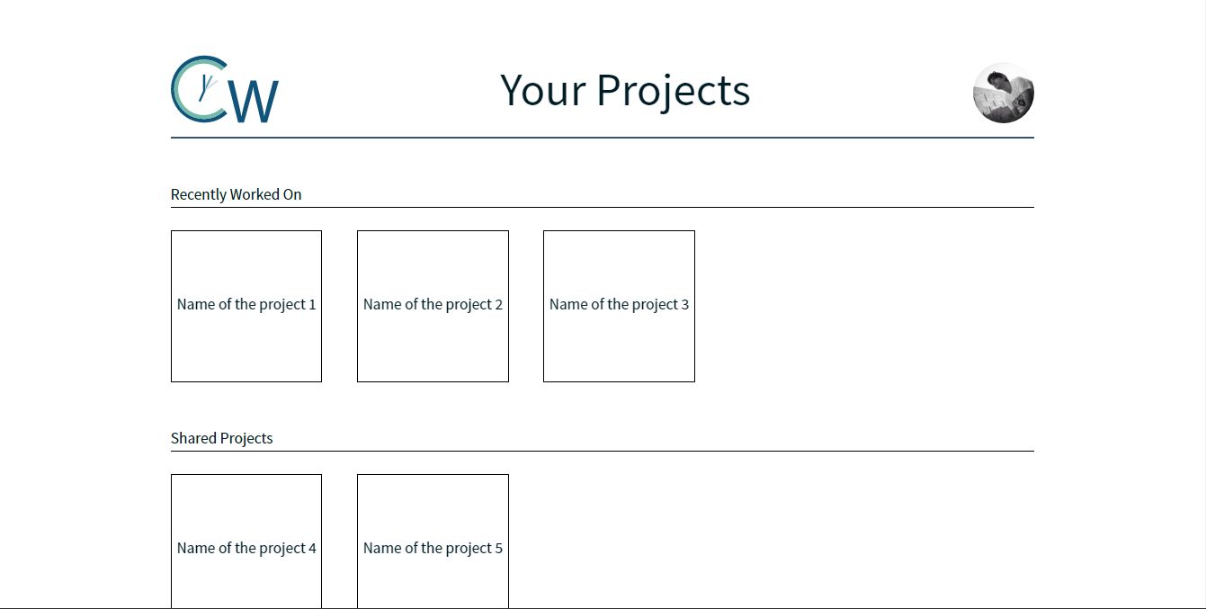When the user has registered or has logged in he / she is shown the project overview. This page consists of a header giving information about your current location in the web app and your profile picture. Underneath the header there are all the different projects the user has created or is part of. They are separated into three different categories: *Recently Worked On, Shared Projects, Your Projects.*

*P2.1: Project overview with some sample projects*

Form this overview the user can select the project he / she would like to navigate to. He / she simply needs to click on one of the rectangles.

# **Time Tracking Page**